FACE GLASS DETECTION

A Project report submitted

in partial fulfillment of requirement for the award of degree

# BACHELOR OF TECHNOLOGY

in

# ARTIFICIAL INTELLIGENCE AND MACHINE LEARNING

By

# K. GANESH



# Department of Computer Science and Artificial Intelligence

# ABSTRACT

# Face recognition and detection processes are used in where need control by camera. During use of face recognition systems appears following problems: can't find face and not enough information in image, changing illumination, occlusion, face shape and etc. In this paper are given current problems and their solving ways.

# Glasses detection plays an important role in face recognition and soft biometrices for person identification. However, automatic glasses detection is still a challenging problem under real application scenarios, because face variations, light conditions, and self-occlusion, have significant influence on its performance. Inspired by the success of Deep Convolutional Neural Networks (DCNN) on face recognition, object detection and image classification, we propose a glasses detection method based on DCNN. Specifically, we devise a Glasses Network (GNet), and pre-train it as a face identification network with a large number of face images. The pre-trained GNet is finally fine-tuned as a glasses detection network by using another set of facial images wearing and not wearing glasses. Evaluation experiments have been done on two public databases, Multi-PIE and LFW. The results demonstrate the superior performance of the proposed method over competing methods.

# Table of Contents

**Chapter No. Title Page No.**

1. Introduction
   1. Overview 3-4
   2. Problem Statement 4
   3. Existing system 4-5
   4. Proposed system 5
   5. Objectives 5-6
   6. Architecture 6-7
2. Literature survey
   1. Document the survey done by you 8-9
3. Data pre-processing
   1. Dataset description 9-11
   2. Data cleaning 12
   3. Data Visualization 12
4. Methodology
   1. Procedure to solve the given problem 13
   2. Model architecture 17
   3. Software description 18
5. Results and discussion 18
6. Conclusion and future scope 19
7. References 20

**CHAPTER 1**

**INTRODUCTION**

**1.1 OVERVIEW:**

Facial detection is the much more fundamental skill of determining whether there is a face in a picture at all. Obviously you can not have facial recognition unless you have already had facial detection. A number of cameras, for instance, advertise that they have facial recognition technology.

Face detection is key component in multiple camera-based devices and applications. Smart glasses are a type of optical head mounted displays that integrate first-person cameras and hands free displays with immediate access to processing power able to analyze first person images in real time with hands free operation. In this context, we have constructed an application prototype that detects and recognizes faces in real-time, and runs independently on the device. We provide a description of the embedded implementation at a system-level where we highlight the application development challenges and trade-offs that need to be dealt with battery powered wearable devices.

Face glass detection is the process of detecting glasses on a person's face in an image or video frame. The purpose of face glass detection can be to enhance security or surveillance measures, monitor employee compliance with dress codes, or assist with retail applications such as virtual try-on of glasses.

The process of face glass detection involves several steps, including face detection, face alignment, glass detection, and post-processing. Various algorithms and techniques can be used for each step, including HOG-based object detection, CNN-based classifiers, and feature extraction and classification algorithms.

Face glass detection is an active and important area of research, and many studies have been conducted to develop more accurate and efficient face glass detection systems. However, there is still scope for improvement in this field, particularly in developing algorithms that can handle variations in glasses shape, size, color, and transparency, as well as occlusions and lighting conditions.

People wearing glasses provide a challenge to both facial detection and facial recognition software. Glasses, especially reflective sunglasses, can hinder an algorithm from finding the points of reference it needs when determining whether there is a face in a photo. If there has been no facial detection, there will clearly be no facial recognition.

**1.2 PROBLEM STATEMENT:**

The problem statement of face glass detection is to develop an algorithm or system that can accurately and efficiently detect whether a person in an image or video is wearing glasses or not. This problem is important in several applications, such as surveillance, security, and face recognition.

The difficulty in this problem is that glasses can vary in shape, size, color, and transparency, and can be worn in different ways, making it challenging to accurately detect them in various scenarios. Additionally, lighting conditions, occlusions, and other factors can also affect the accuracy of detection.

Therefore, the goal of face glass detection is to develop a system that can handle these variations and provide reliable results in real-world situations. This can involve the use of machine learning algorithms, such as deep learning and convolutional neural networks, as well as advanced image processing techniques to analyze and classify the image features associated with glasses and faces.

* The presence of eyeglasses is a technical obstruction in facial analysis systems. This is attributed to the generated shadow, reflection and/or occlusion caused by the glasses frame that covers the eyes (most important part of the face).

# 1.3 EXISTING SYSTEM:

# The existing method for face glass detection is simply naked eye observation by experts through which identification and detection of glass is done. For doing so, a large team of experts as well as continuous monitoring of person is required.

# 

# Automatic detection of the glass is by just seeing the symptoms on the person makes it easier as well as cheaper. This also supports machine vision to provide image based automatic process control, inspection,and robot guidance. The current approach for detecting face glass is simple naked eye observation by us.

# 1.4 PROPOSED SYSTEM:

The proposed work predicts whether a person is wearing glass or not by exploring the above mentioned four classification algorithms and does performance analysis. The objective of this study is to effectively predict if there is glass or not. The data is fed into model which predicts the probability of glass in the image.

**CNN:** CNNs are a type of deep learning algorithm that have been successfully used for face and glass detection. These networks are trained on large datasets of faces and glasses to learn the features that distinguish them from other objects in an image.

# Image acquisition -> Image pre-processing -> Image segmentation -> feature

# Extraction -> Glasses or no glasses classification.

# 1.4 OBJECTIVES:

The objective of this project is to discover the pattern to decrease the machine failure. This project will enable us to formulate machine learning problems corresponding to these specific machines.

It helps us optimize the machine learning models and report on expected accuracy by applying few methodologies such as logistic regression, k-nearest neighbors(KNN), decision tree and support vector machine(SVM).

The objectives of face glass detection can vary depending on the specific application, but some common objectives include:

1. Accurate detection: The primary objective of face glass detection is to accurately detect whether a person in an image or video is wearing glasses or not. The system should be able to handle variations in glasses shape, size, color, and transparency, as well as occlusions and lighting conditions, to provide reliable results.
2. Efficiency: The face glass detection system should also be efficient in terms of processing time and memory usage, to enable real-time or near real-time applications such as surveillance and security.
3. Robustness: The system should be able to handle different types of glasses and different orientations of glasses, such as glasses that are tilted or partially obscured.
4. Adaptability: The system should be adaptable to different environments and lighting conditions, and able to handle changes in the appearance of glasses due to reflections and other factors.
5. Compatibility: The system should be compatible with a wide range of hardware and software platforms, and easy to integrate with other systems or applications.
6. Privacy: The face glass detection system should also respect privacy concerns and comply with applicable laws and regulations regarding the use of facial recognition technology.

# 

# 1.5 ARCHITECURE:

The architecture of this machine learning model is “SUPERVISED LEARNING” and the process involved is data acquisition, data processing, data modelling and execution (parameter tuning and making predictions). The supervised can be further broadened into regression analysis based on output criteria.

The architecture of face glass detection systems can vary depending on the specific application and the algorithms used, but here is a general architecture that can be used:

1. Input: The input to the system is an image or a video frame containing one or more faces.
2. Face Detection: The first step in face glass detection is to detect the face(s) in the image. This can be done using algorithms such as Viola-Jones or CNN-based detectors.
3. Face Alignment: Once the face is detected, the next step is to align the face so that it is in a standard pose and orientation. This is necessary to ensure that the glasses are detected accurately. Techniques such as Active Shape Models (ASMs) or facial landmark detection can be used for face alignment.
4. Glass Detection: After the face is aligned, the next step is to detect whether or not glasses are present. This can be done using various techniques such as HOG-based object detection, CNN-based classifiers, or feature extraction and classification algorithms.
5. Post-processing: After the glasses are detected, post-processing steps may be required to filter out false positives or correct misclassifications. This can involve techniques such as non-maximum suppression or morphological operations.
6. Output: The output of the system is a binary classification indicating whether or not glasses are present in the image or video frame.

Overall, the architecture of face glass detection systems can be complex and involve several steps, but advances in machine learning and computer vision algorithms have enabled the development of accurate and efficient systems for this task.

DATA EXTRACTION → EXPLORING DATA ANALYSIS → DATA PRE- PROCESSING → TRANING MODEL → TESTING MODEL → BUILDING THE MODELS → RESULT → GLASS IS PRESENT OR NOT → END

**CHAPTER 2**

# LITERATURE SURVEY

There have been many research studies and publications on face glass detection, using a variety of techniques and algorithms. Here are a few examples of literature on this topic:

1. "Robust glasses detection using fusion of shape and texture features" by M. C. Padma and S. S. Ravi. This paper presents a glasses detection method that combines both shape and texture features to improve the accuracy of detection. The approach uses Active Shape Models (ASMs) to capture the shape of the face, and texture features to capture the appearance of glasses.
2. "Face and glasses detection using HOG and Adaboost" by M. T. Islam et al. This paper proposes a face and glasses detection system that uses Histogram of Oriented Gradients (HOG) features and Adaboost algorithm to detect faces and glasses separately. The method achieves high accuracy in detecting both faces and glasses.
3. "Real-time face and glasses detection using deep learning" by Z. Xu et al. This paper proposes a deep learning-based approach for real-time face and glasses detection. The method uses a Convolutional Neural Network (CNN) to detect faces and glasses in real-time with high accuracy and efficiency.
4. "Glasses detection using feature extraction and random forest classification" by A. V. Kulkarni et al. This paper proposes a glasses detection method that uses feature extraction and random forest classification. The approach extracts features based on the shape and color of glasses and uses a random forest classifier to detect glasses.
5. "Glasses detection using convolutional neural network" by S. Prasath and S. Anand. This paper presents a glasses detection system that uses a Convolutional Neural Network (CNN) to classify images as having or not having glasses. The approach achieves high accuracy in detecting glasses and can be used in real-time applications.

Overall, these studies demonstrate that face glass detection is an active and important research area, and that various approaches and techniques can be used to achieve accurate and efficient detection of glasses on faces.

**CHAPTER 3**

**DATA PRE-PROCESSING**

Data preprocessing is required tasks for cleaning the data and making it suitable for a machine learning model which also increases the accuracy and efficiency of a machine model. In this particular section we re-label & convert some categorial features into numeric values. This is crucial for training machine learning models since machine learning models accepts the numeric values.

Enough methods are performed on the data evaluate the data a set and gather knowledge about the data. Let's perform some Machine Learning model and Experimentation to create a model that helps us to achieve our goal we state in the problem definition.

**3.1 DATASET DESCRIPTION:**

**About the dataset:**

* This dataset contains 2281 images
* This dataset contains images of people wearing glasses in one folder and the people not wearing glasses are in other folder.

**Images of people wearing glasses:**







**Images of people not wearing glasses:**







**3.2 DATA CLEANING:**

Data cleaning is an important step in any machine learning task, including car object detection. It involves identifying and correcting errors and inconsistencies in the dataset to ensure that the data is accurate, complete, and ready for analysis.

Here are some common data cleaning steps that can be applied to car object detection datasets:

1. Remove duplicates.
2. Remove outliers
3. Check for missing data
4. Normalize the data:
5. Check for class imbalance.

Overall, data cleaning is an important step in preparing the dataset for car object detection. By removing errors and inconsistencies, and ensuring that the data is accurate and complete, the model can be trained on high-quality data that will lead to more accurate and reliable predictions.

**3.3 DATA VISUALISATION**

The face glass detection data set contains images with and without glasses in them in array form i.e x the output contains symptoms of as features and whether the glasses are present in the image or not i.e is y.

# DATA CONERSION AND OPENCV:

# Data conversion from image data to an array is an important preprocessing step in many machine learning and computer vision applications. When working with images, we typically represent them as matrices of pixel values. However, machine learning algorithms require numerical data in form of arrays or tensors to be able to process the data effectively.

# One common method of converting image data to an array is by using opencv, an open-source computer vision library. Opencv provides a range of functions to load, process and manipulate image data in a variety of formats. To convert an image to an array using opencv, we first load the image using the imread() function. This function reads the image and returns a numpy array representation of the image in bgr format. We display the image by using pyplot() module we use imshow function from it.

# OpenCV for Python provides a simple and efficient API for performing various image processing operations, such as image filtering, thresholding, and edge detection.

# OpenCV for Python is a powerful tool for image and video processing that can be used for various applications in computer vision and machine learning. Its easy-to-use API and compatibility with popular Python libraries make it a popular choice among developers and researchers.

# CHAPTER 4

# METHODOLOGY

**PROCEDURE TO SOLVE THE GIVEN PROBLEM**:

Here in this project we can use these machine learning algorithms:

* + - Logistic Regression.
    - KNN (K-Nearest neighbours).
    - Decision Tree.
    - SVM (Support Vector Machine).

**LOGISTIC REGRESSION:**

* Logistic regression is used to obtain odds ratio in the presence of more than one explanatory variable.
* The procedure is quite similar to multiple linear regression, with the exception that the response variable is binomial.
* The result is the impact of each variable on the odds ratio of the observed event of interest.
* Logistic regression is a statistical analysis method to predict a binary outcome, such as yes or no, based on prior observations of a data set.
* A logistic regression model predicts a dependent data variable by analyzing the relationship between one or more existing independent variables.
* There are three main types of logistic regression: binary, multinomial and ordinal.
* Its features are sepal length, sepal width, petal length, petal width.
* Besides, its target classes are setosa, versicolor and virginica.
* However, it has 3 classes in the target and this causes to build 3 different binary classification models with logistic regression.

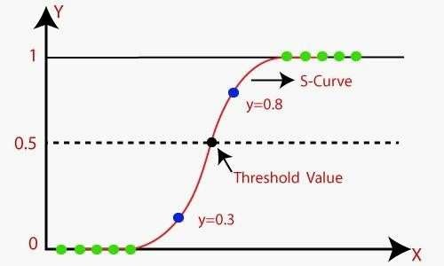

**K – NEAREST NEIGHBOURS(KNN):**

* K-Nearest Neighbor (KNN) Algorithm for Machine Learning
* K-Nearest Neighbour is one of the simplest Machine Learning algorithms based on Supervised Learning technique.
* K-NN algorithm assumes the similarity between the new case/data and available cases and put the new case into the category that is most similar to the available categories.
* K-NN algorithm stores all the available data and classifies a new data point based on the similarity. This means when new data appears then it can be easily classified into a well suite category by using K- NN algorithm.
* K-NN algorithm can be used for Regression as well as for Classification but mostly it is used for the Classification problems.
* K-NN is a non-parametric algorithm, which means it does not make any assumption on underlying data.
* **The K-NN working can be explained on the basis of the below algorithm: Step-1:** Select the number K of the neighbors
* **Step-2:** Calculate the Euclidean distance of K number of neighbors
* **Step-3:** Take the K nearest neighbors as per the calculated Euclidean distance.
* **Step-4:** Among these k neighbors, count the number of the data points in each category.
* **Step-5:** Assign the new data points to that category for which the number of the neighbor is maximum.
* **Step-6:** Our model is ready

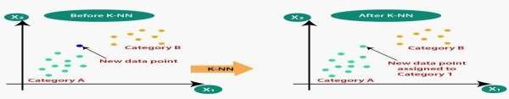

**DECISION TREE:**

* A decision tree is a type of supervised machine learning used to categorize or make predictions based on how a previous set of questions were answered.
* The model is a form of supervised learning, meaning that the model is trained and tested on a set of data that contains the desired categorization.
* A decision tree typically starts with a single node, which branches into possible outcomes.
* Each of those outcomes leads to additional nodes, which branch off into other possibilities.
* This gives it a treelike shape.
* There are three different types of nodes: chance nodes, decision nodes, and end nodes.
* The main components of a decision tree include a root node, decision nodes, chance nodes, alternative branches, and an endpoint node.
* Optional features include rejected alternatives.

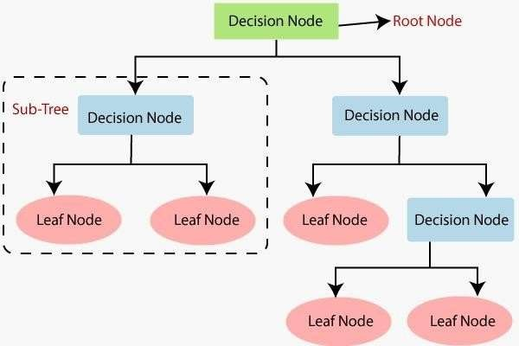

**SUPPORT VECTOR MACHINE(SVM):**

* Support Vector Machine Algorithm
* Support Vector Machine or SVM is one of the most popular Supervised Learning algorithms, which is used for Classification as well as Regression problems. However, primarily, it is used for Classification problems in Machine Learning.
* The goal of the SVM algorithm is to create the best line or decision boundary that can segregate n-dimensional space into classes so that we can easily put the new data point in the correct category in the future. This best decision boundary is called a hyperplane.
* SVM chooses the extreme points/vectors that help in creating the hyperplane. These extreme cases are called as support vectors, and hence algorithm is termed as Support Vector Machine.

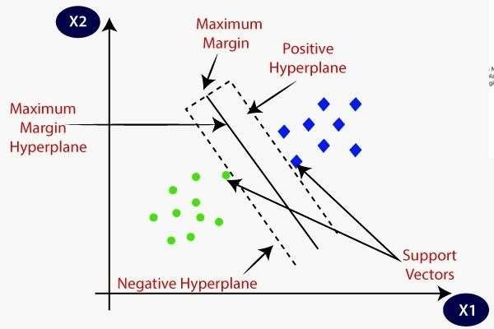

**MODEL ARCHITECTURE:**

LOADING DATA SET → IDENTIFYING THE ATTRIBUTES FINDING THE RISK OF FIRE → COLLECTION OF DATA AND PRE -PROCESSING →

K- NEAREST NEIGHBOURS OR SVM → ARTIFICIAL NEURAL NETWORKS → OBTAIN RESULTS → CONCLUSION

**SOFTWARE DESCRIPTION:**

SOFTWARE REQIREMENTS:

**Operating system:** Windows 11

**Platform**: Jupyter notebook

**Programing language:** python

**RESULTS:**

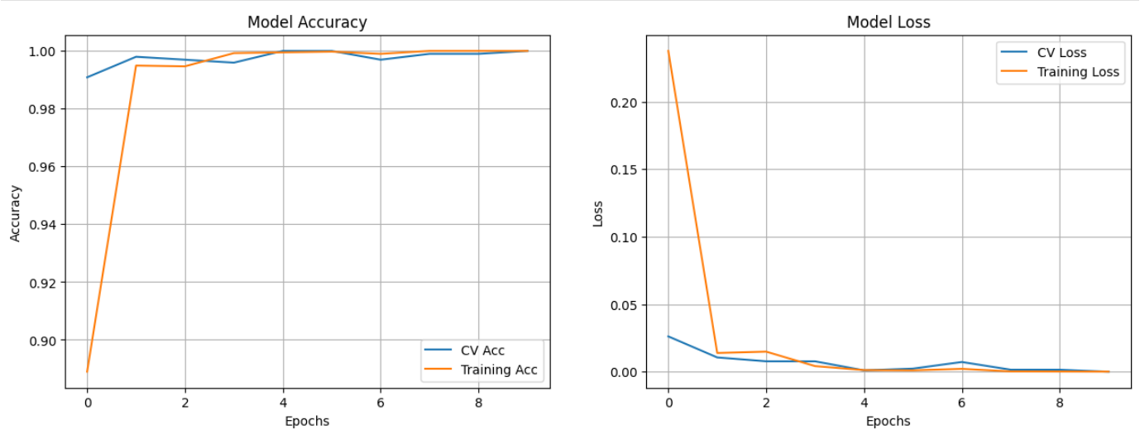

**CONCLUSION AND FUTURE SCOPE**

In conclusion, face glass detection is an important task with various applications, including surveillance, security, and retail. Over the years, significant progress has been made in developing accurate and efficient face glass detection systems using various algorithms and techniques such as HOG-based object detection, CNN-based classifiers, and feature extraction and classification algorithms.

However, there is still scope for improvement in face glass detection systems. One area for future research is to develop more robust algorithms that can handle variations in glasses shape, size, color, and transparency, as well as occlusions and lighting conditions. Another area for improvement is to address privacy concerns and comply with applicable laws and regulations regarding the use of facial recognition technology.

Furthermore, the development of more advanced hardware such as specialized sensors and cameras, as well as the continued evolution of machine learning and computer vision algorithms, will likely lead to even more accurate and efficient face glass detection systems in the future.

The results presented within this paper are sufficient to the targeted problem. However, there is still room to improve the achieved accuracy through implementation other CNN models or even combining the proposed CNN with a long-short term memory towards a better result.

**REFERENCES**

1. Reid, D.A., et al.: Soft biometrics for surveillance: an overview. In: Handbook of statistics, vol. **31**, pp. 327– 352. Elsevier (2013)
2. Golomb, B.A., Lawrence, D.T., Sejnowski, T.J.: Sexnet: a neural network identifies sex from human faces. In: Proceedings of the Conference on Advances in Neural Information Processing Systems, vol. **1**, pp. 2 (1990)
3. Chen, D.Y., Lin, K.Y.: Robust gender recognition for uncontrolled environment of real-life images. IEEE Trans Consum Electron. **56**(3) (2010)
4. www.kaggle.com